**Implementing CRM for Result tracking of a Canditate with Internal marks**

|  |  |
| --- | --- |
| **Date** | **20th April 2023** |
| **Team ID** | **NM2023TMID33384** |
| **Project Name** | **Implementing CRM for Result tracking of a Canditate with Internal marks** |
| **Team Leader** | **ARUNRAJ.R** |
| **Team Member** | **ARTHI.B** |
| **BARATHI.V** |
| **BAVITHRA.D** |

**1 INTRODUCTION**

* 1. **Overview**

Our project aims to improve the functionality of an exsisting Implementing CRM for Result of a candidate with internal marks.we achive this goal by creating custom object ,relationship,and page layouts that provides easy access to the relevant data

* 1. **Purpose**

Welcome to salesforce! Salesforce is game-changing technology with a host of productivity-boosting features ,

that will help you sell smarter and faster. As you work toward your badge for this module,we’ll take you through these features and answer the question, “what is salesforce,anyway?”

# 2 PROBLEM DEFINITION & DESING THINKING

* 1. **Empathy Map**

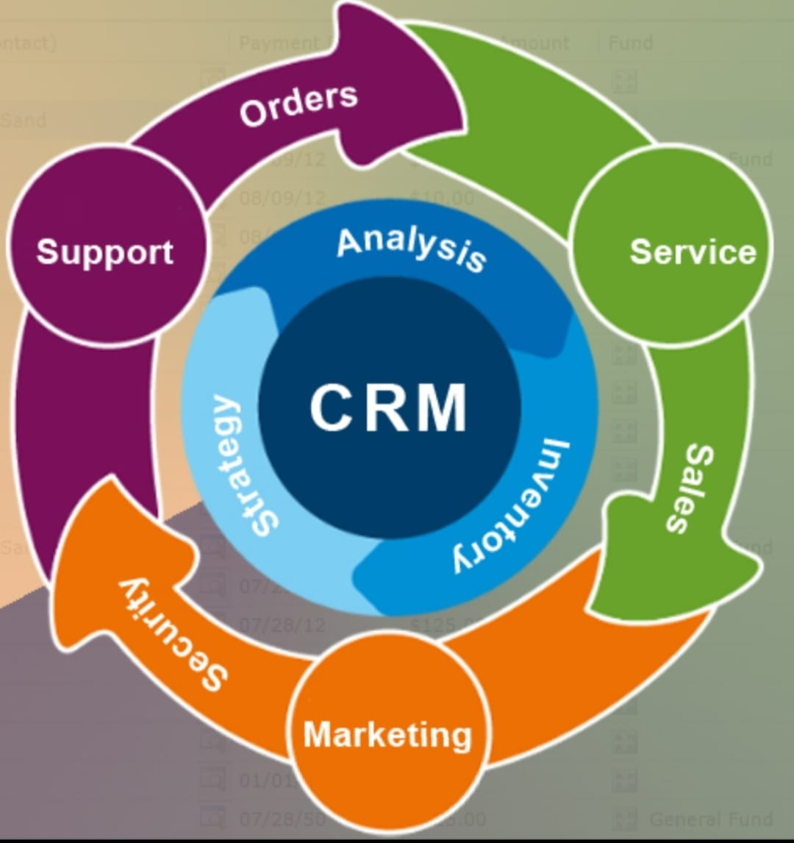

* 1. **Ideation & Brainstorming Map**

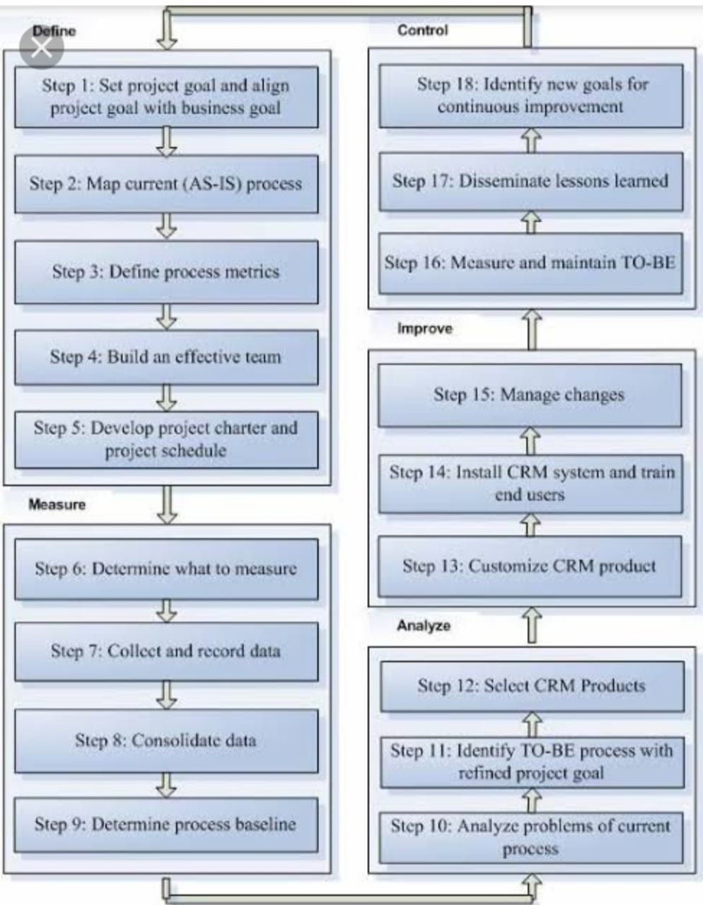

# 3 RESULT

* 1. **Data Model**

|  |  |  |
| --- | --- | --- |
| Object Name | Fields in the Object | |
| Field Label | Date Type |
| candidate | Candidate | Text(18) |
| Course detail | Text(17) |
| Internal result object | Text(12) |
| Lecture detail | Text(7) |
| Course detail | Name | Text(80) |
| CreatedBy | Lookup(user) |
| LastModifiedBy | Lookup(user) |
| Owner | Lookup(user,group) |
| Internal result object | CreatedBy | Lookup(user) |
| Name | Text(80) |
| LastModifiedBy | Lookup(user) |
| Owner | Lookup(user,group) |
| Lecture detail | CreatedBy- | Lookup(user)- |
| LastModifiedBy | Lookup(user) |
| Name | Text(80) |
| Owner | Lookup(user,group) |
| semester | CreatedBy | Lookup(user) |
| LastModifiedBy | Lookup(user) |
| Owner | Lookup(user,group) |
| Name | Text(80) |

* 1. **Activity & Screenshot Milestone 1:**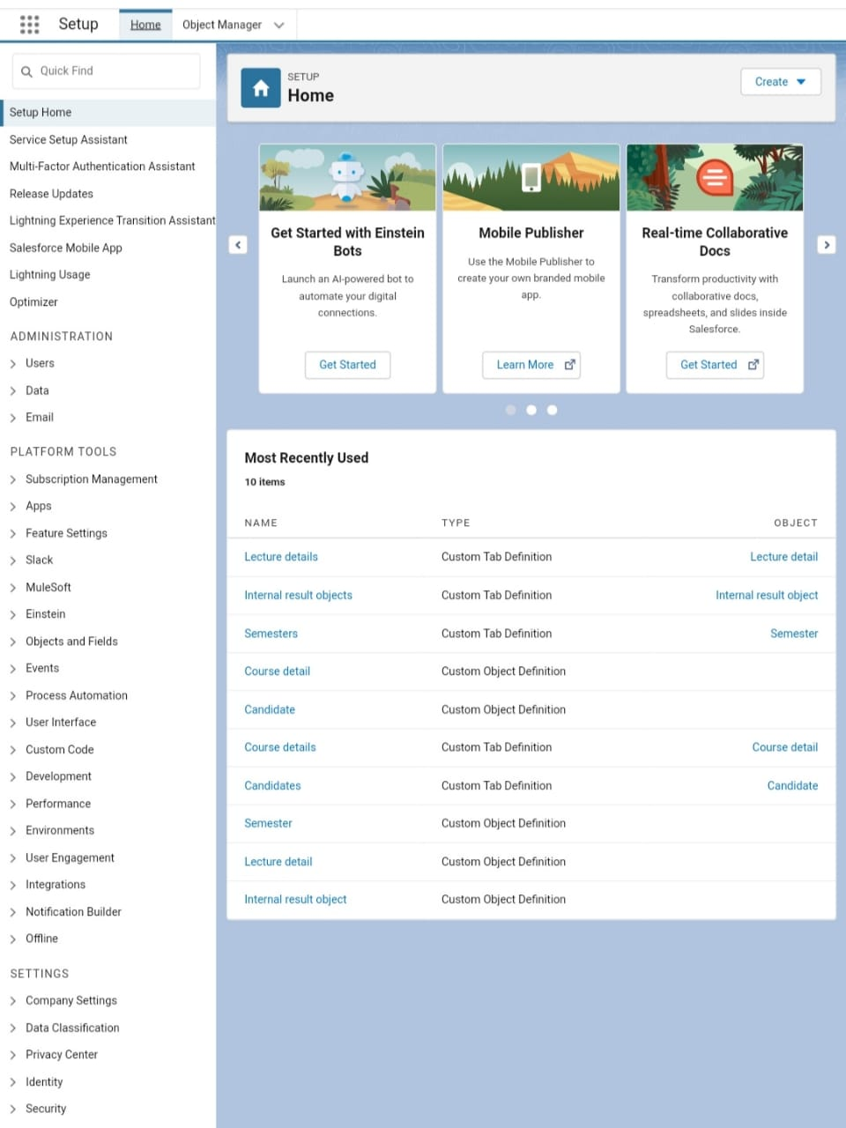

**Creation of Result tracking.**

Milestone 2:

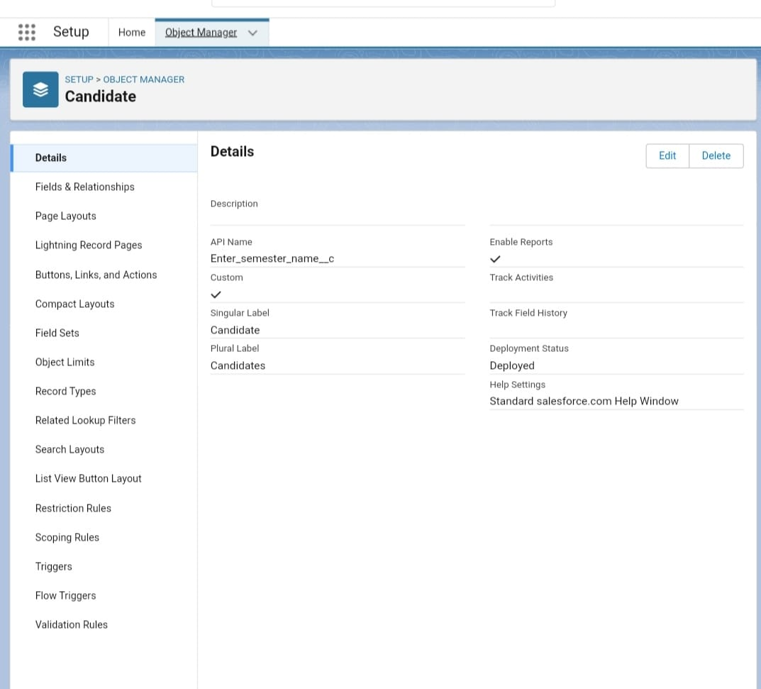

Candidate for Recruting App.

Milestone 3:

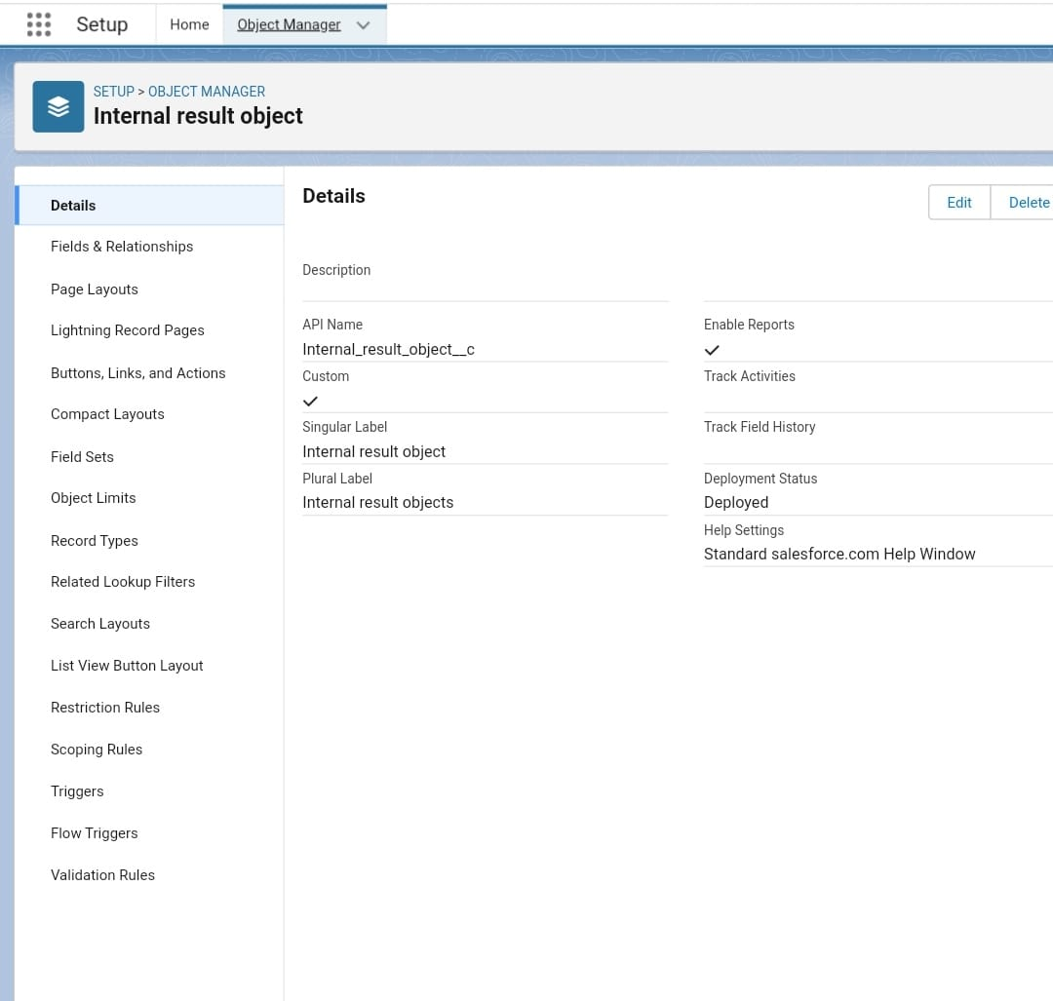

Internal Result of Objects

Milestone 4 :

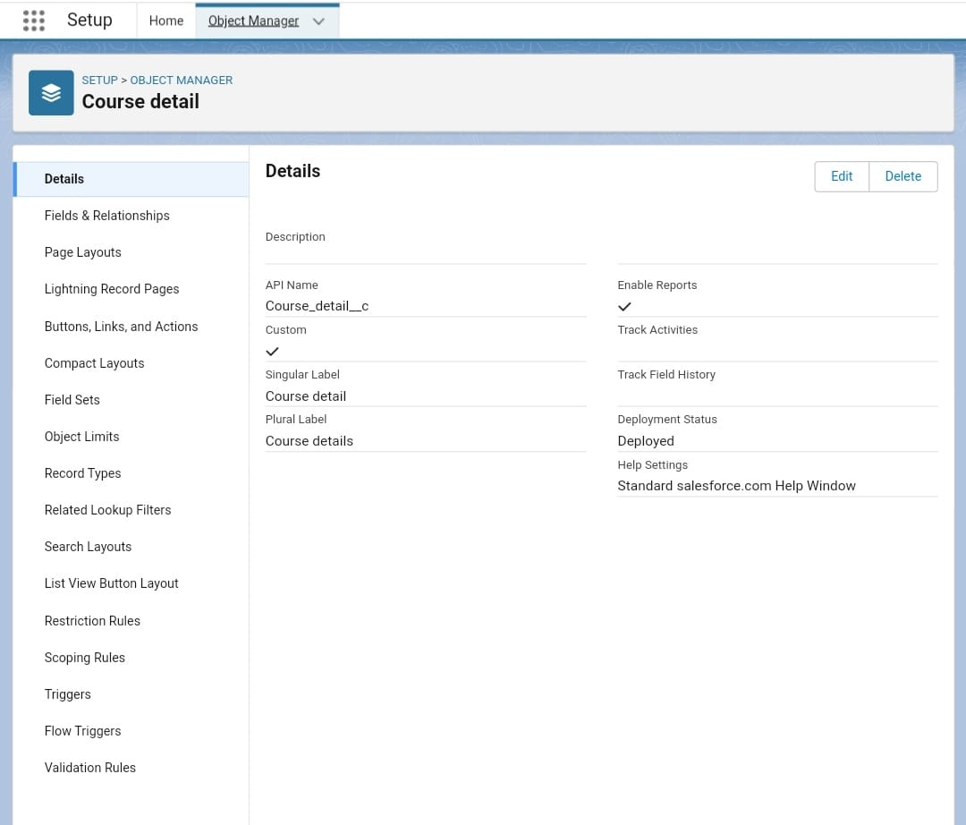

Creation of Course Detail

Milestone 5:

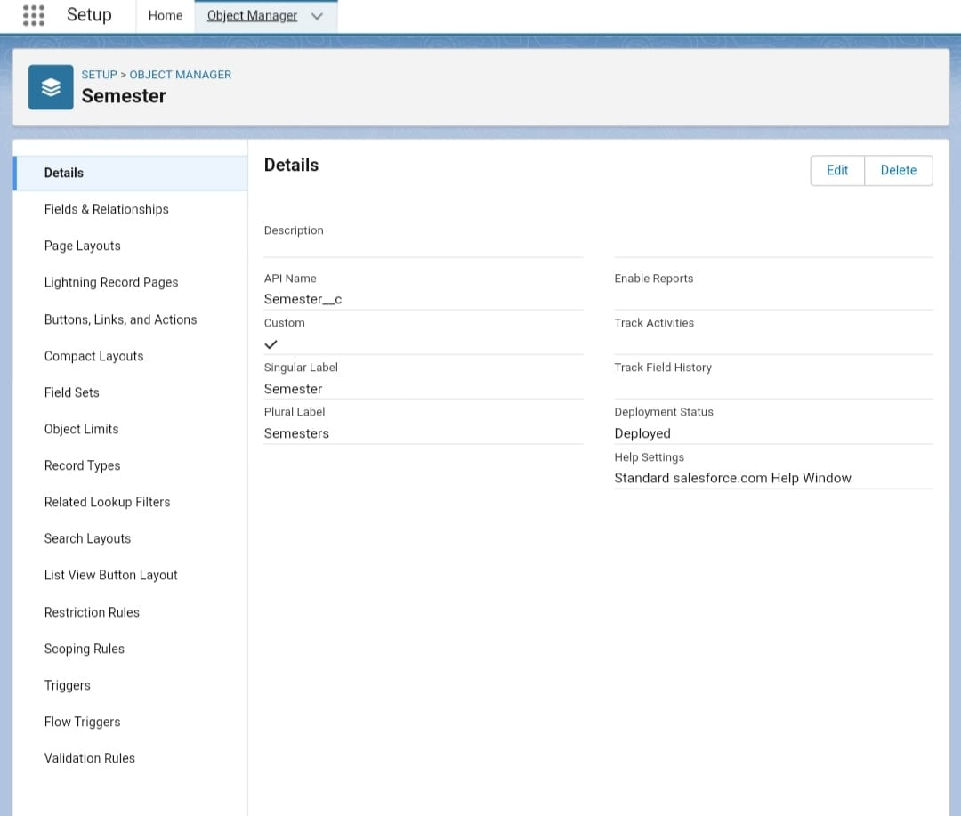

Creation of Semester

Milestone 6:

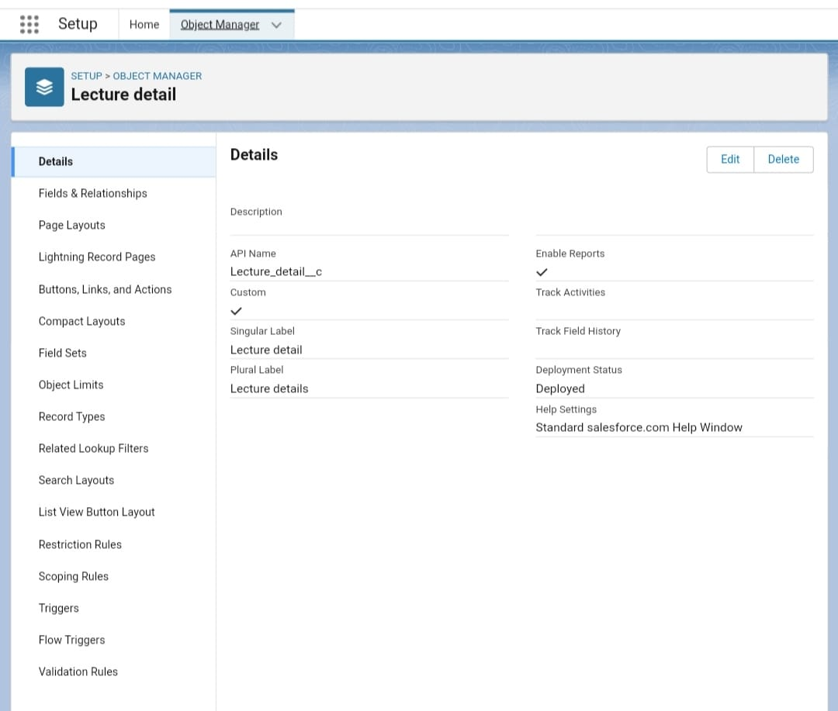

Creation of Lecture Detail

Milestone 7:

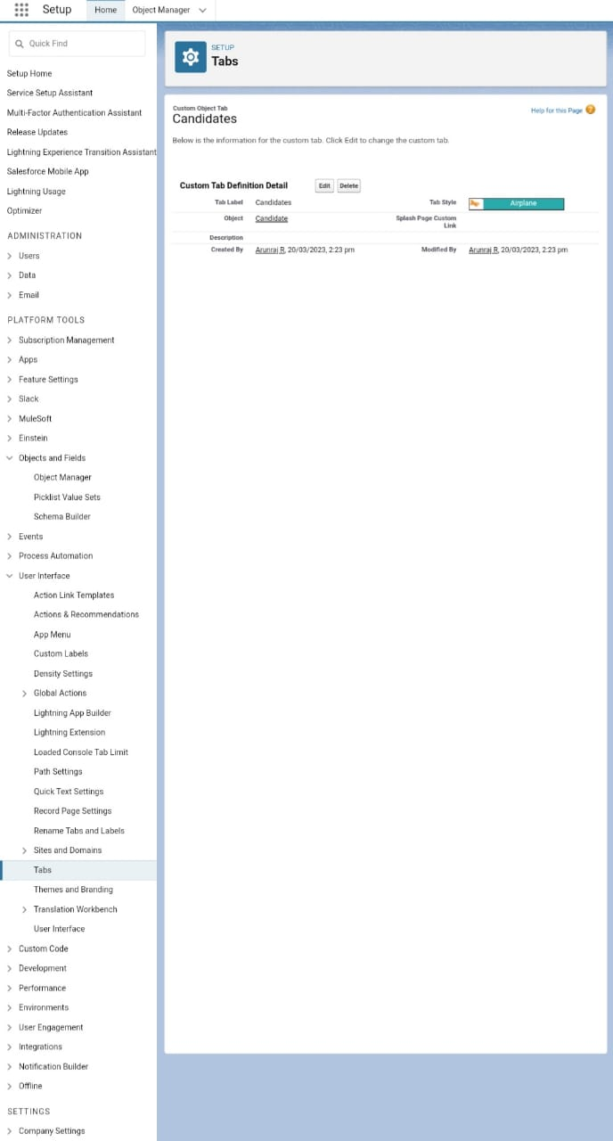

Creation of Canditates

Milestone 8:

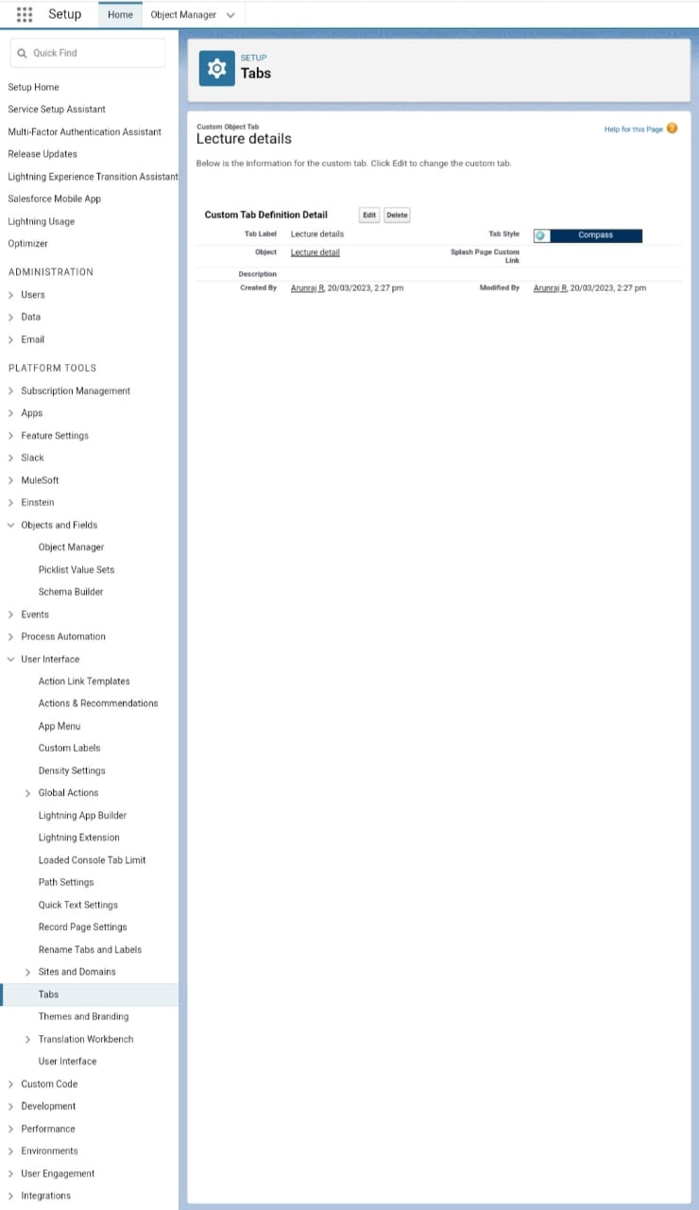

Creation of Tabs ( Lectural Details)

Milestone 9:

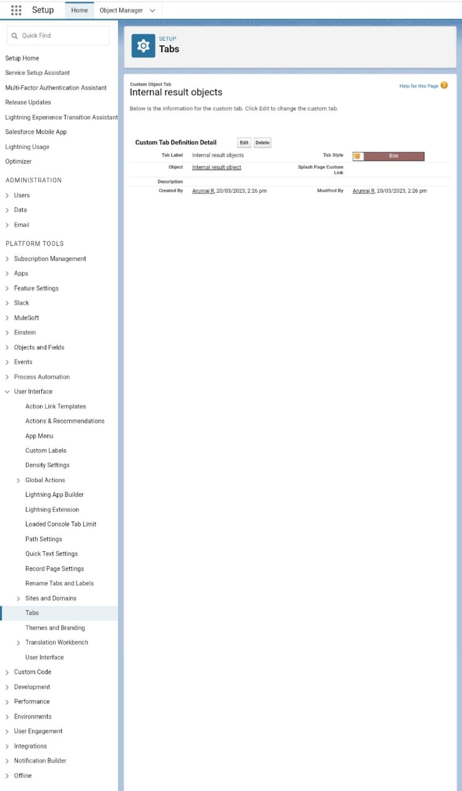

Creation of Tabs (Internal Result Objects)

Milestone 10:

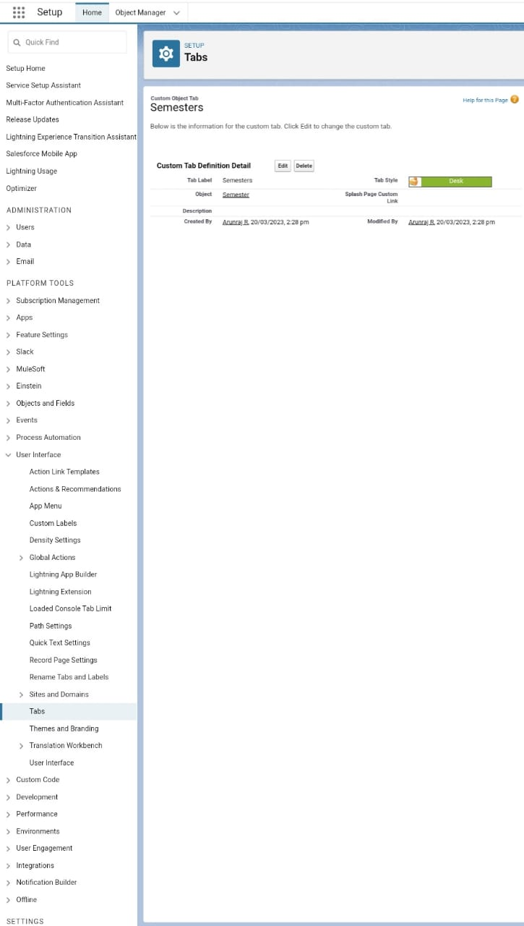

Creation of Tabs (Semester)

Milestone 11:

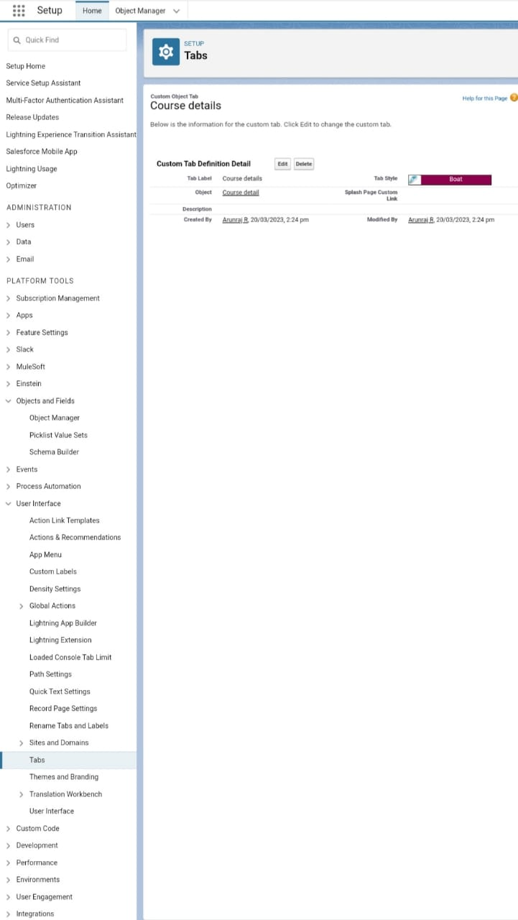

Creation of Tabs (Course Details)

Milestone 12:

Createion of Reports (New account report & private report )

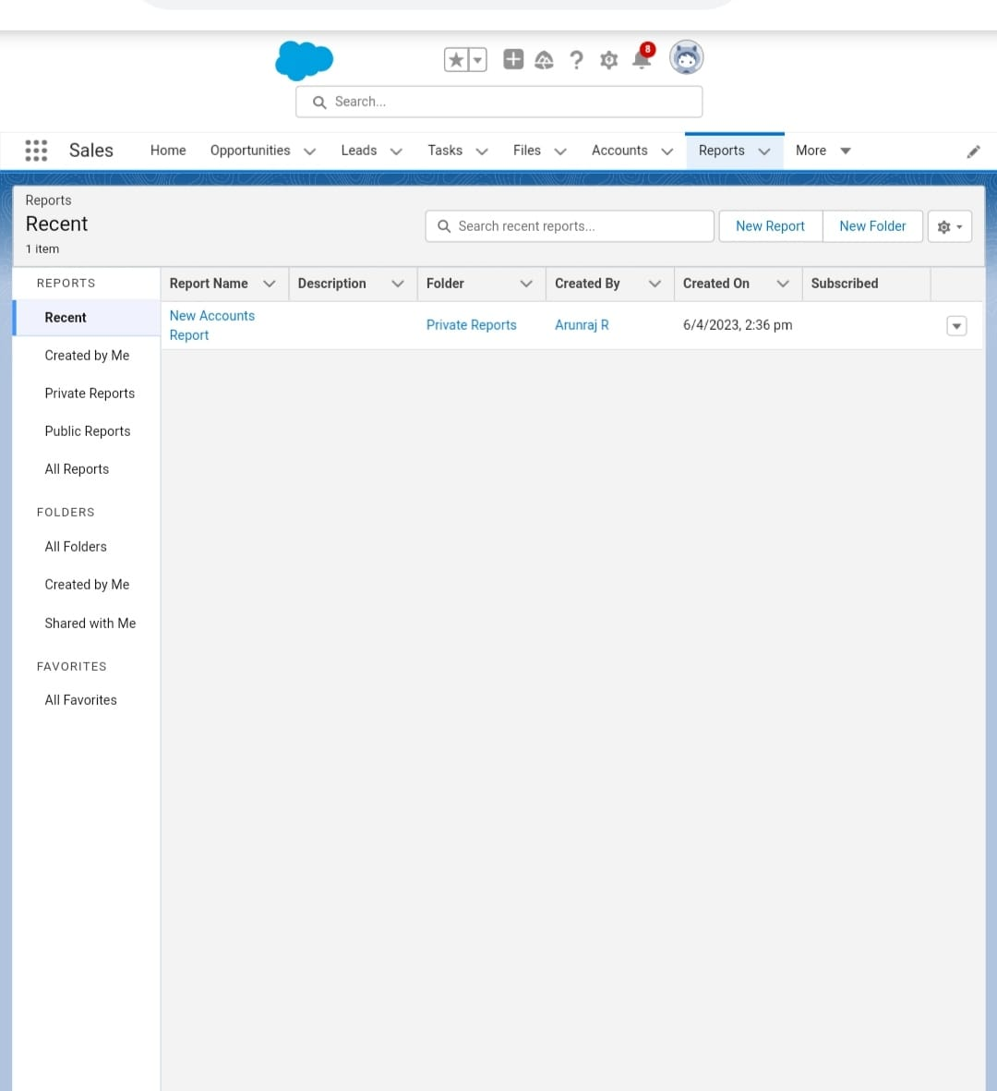

# 4 TRAILHEAD PROFILE PUBLIC URL

Team Lead - https://trailblazer.me/id/arunraj90

Team Member 1 - https://trailblazer.me/id/aarthii1

Team Member 2 - https://trailblazer.me/id/bbarathi2

Team Member 3 - https://trailblazer.me/id/bdhaya1

# 5 ADVANTAGES & DISADVANTAGES

* Data entry can be automated.
* An efficient dashboard streamlines sales activities.
* Burdensome data entry.
* Dependent on proper setup.

# 6 APPLICATIONS

* It used in Administrator should be able to create all bass data including semester,candidate, course ,etc.
* Its used to easy calculated in internal results.
* Its used to mostly update internal marks, results, to the semestyer exams.

# 7 CONCULUSION

* To enhance the efficiency of the app.

# 8 FUTURE SCOPE

In the 21st century each and every field is computerized and all results, internal marks, to semester exam to the higher education . so it has a good future.